Chapter 3, Solution 17
60 V
–
+
60 V
4 Ω
10 Ω
2 Ω
8 Ω
3i₀
i₀
v₁
v₂

At node 1, 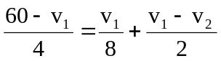 120 = 7v₁ - 4v₂ (1)
At node 2, 3i₀ + 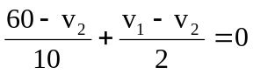

But i₀ = 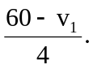

Hence

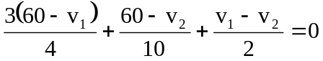 1020 = 5v₁ + 12v₂ (2)

Solving (1) and (2) gives v₁ = 53.08 V. Hence i₀ = 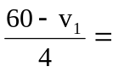 1.73 A

